1. AKI HARLEY (VIA TELFON)
2. 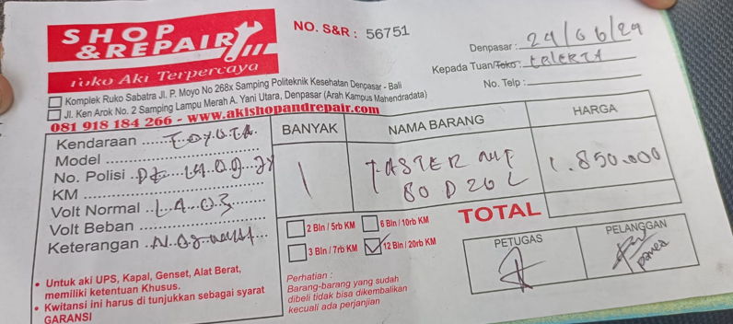AKI VELLFIRE
3. 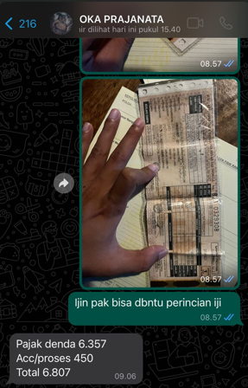PAJAK WULING ALMAZ
4. TOWING MOBIL MAZDA CX30, ALPHARD, MINI CLUBMAN (VIA TELFON)
5. SERVICE KARBON FERRARI (VIA TELFON)
6. PASANG RIBEN FERRARI (VIA TELFON
7. PASANG RIBEN MERCY E250 (VIA TELFON)
8. SURAT JALAN 3 (via telfon)
9. CAT RONY:
   1. 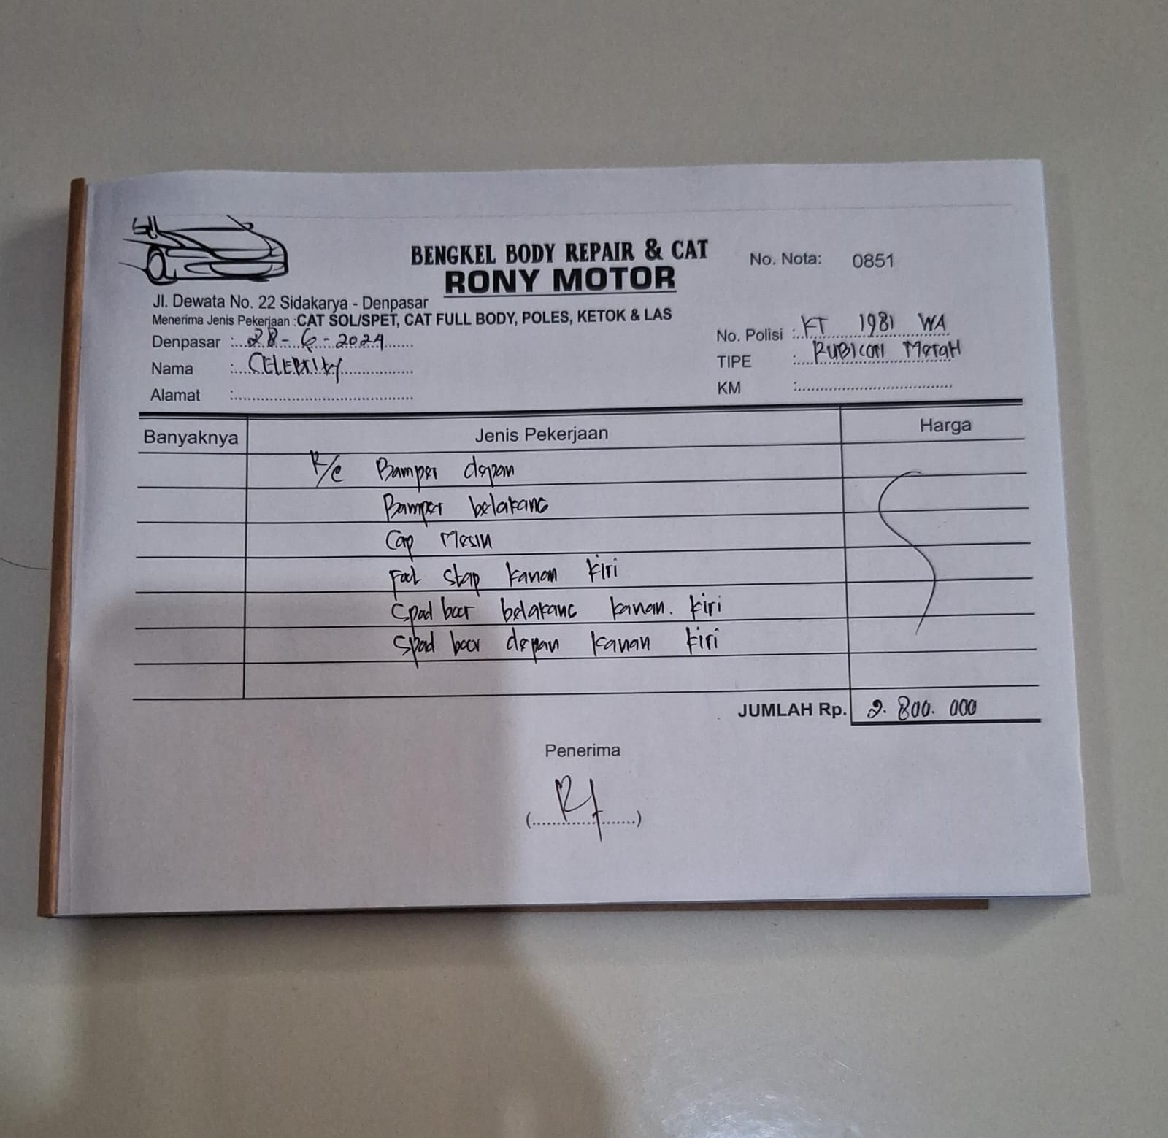RUBICON MERAH
   2. 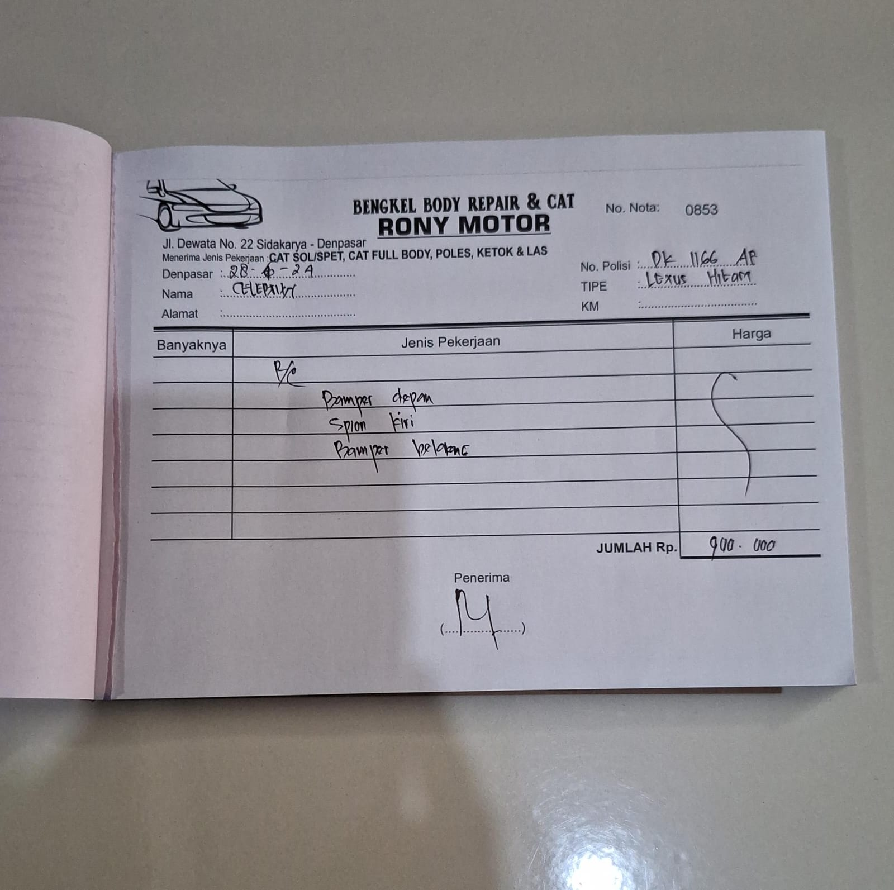LEXUS NX HITAM
   3. 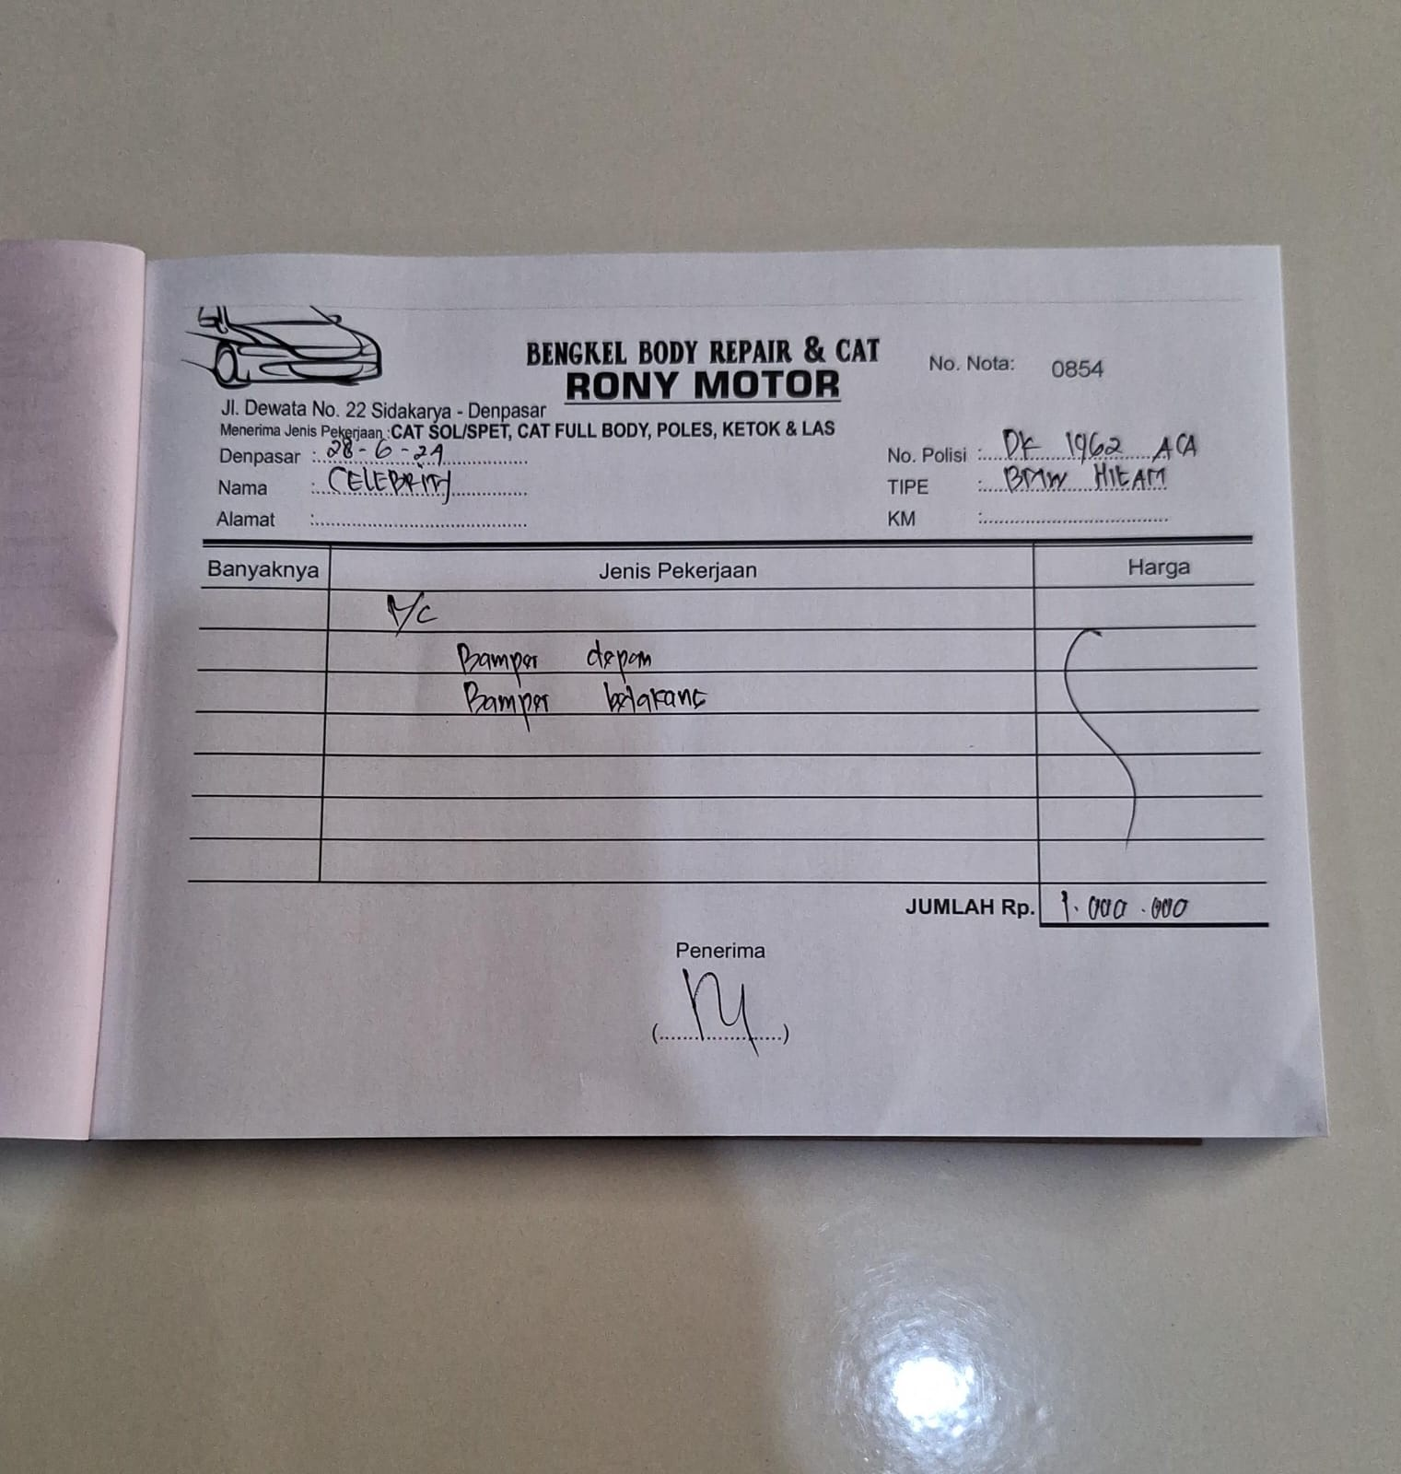BMW X3 HITAM
   4. MAZDA MX-5

